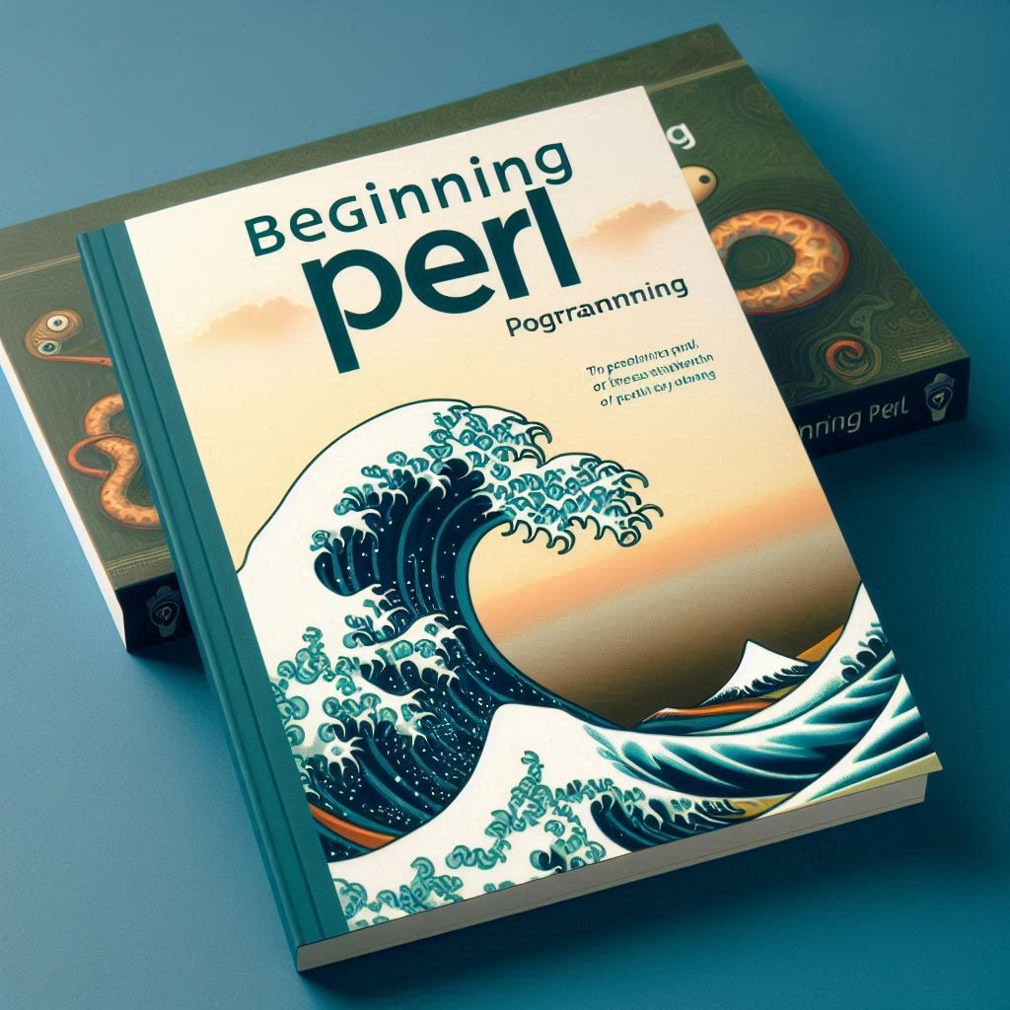

Beginners Guide to Perl Programming

An introduction and overview
Welcome to Beginning Perl Programming, your comprehensive guide to mastering the basics of Perl. This booklet is designed for beginners who are eager to dive into the world of Perl programming. Whether you are new to programming or looking to expand your skills, this booklet will provide you with the foundational knowledge you need to get started.
This booklet is not only a learning resource but also a handy reference guide that you can return to whenever you need a quick refresher on Perl concepts. With “Beginning Perl Programming,” you’ll be well-equipped to tackle real-world programming challenges and continue your journey towards becoming a proficient Perl programmer.

By Randall Fadler September 2024
Contents
History of Perl Programming Language 3
Introduction to Perl 4
Installing Perl 4
Writing Perl Scripts 5
Creating a Perl Script 5
Explaination 5
Running a Perl Script 6
Basic Syntax and Data Types 6
Comments 6
Variables 6
Scalars 6
Arrays 6
Hashes 6
Control Structures 7
Subroutines: 7
Detailed Examples with Explanation 7
Using Regular Expressions: 8
Working with Arrays: 8

History of Perl Programming Language
Perl is a high-level, general-purpose, interpreted, dynamic programming language. It was developed by Larry Wall in 1987 as a Unix scripting language to make report processing easier¹². The name “Perl” is often said to stand for “Practical Extraction and Report Language,” though this is a backronym and not an official acronym².
Early Development
Larry Wall, a linguist and programmer, created Perl to fill a gap between shell scripting and more complex programming languages like C. The first version of Perl, Perl 1.0, was released on December 18, 1987². It was designed to be a flexible and powerful tool for text processing and system administration tasks.
Evolution and Growth
Perl quickly gained popularity due to its powerful text manipulation capabilities and its flexibility. It borrowed features from other programming languages such as C, AWK, sed, and Unix shell scripting¹. Over the years, Perl underwent many changes and revisions:
- Perl 4: Released in 1991, this version solidified Perl’s reputation as a powerful scripting language. The famous “Camel Book,” Programming Perl, was published around this time, further popularizing the language².
- Perl 5: Released in 1994, Perl 5 introduced significant improvements, including better support for object-oriented programming, modules, and references¹. This version remains widely used today and continues to receive updates and support from the Perl community.
Modern Usage
Perl gained widespread popularity in the mid-1990s as a CGI scripting language, thanks to its powerful regular expression and string parsing abilities¹. It has been used in various domains, including system administration, network programming, finance, bioinformatics, and web development¹. Perl is often referred to as “the Swiss Army chainsaw of scripting languages” due to its flexibility and power¹.

Perl 6 and Raku
From 2000 to 2019, a new version of Perl, known as Perl 6, was in development. In 2019, it was renamed Raku to distinguish it from Perl 5¹. Both Perl 5 and Raku continue to be developed independently by different teams, each borrowing ideas from the other¹.
Community and Culture
Perl has a vibrant and active community, with many online resources, user groups, and conferences dedicated to the language. The Comprehensive Perl Archive Network (CPAN) is a vast repository of Perl modules and libraries, making it easy for developers to find and share code¹.
Perl’s mascot is the camel, popularized by the cover of the “Camel Book,” and its logo is an onion, symbolizing the many layers of the language¹.
Perl remains a valuable tool for many developers, and its legacy continues to influence modern programming languages and practices.

Introduction to Perl
Perl, often referred to as the “Swiss Army chainsaw” of programming languages, is a high-level, general-purpose language known for its powerful text processing capabilities and flexibility. Developed by Larry Wall in 1987, Perl was initially designed for text manipulation and report generation, but it has since evolved into a versatile language used for a wide range of applications, including web development, system administration, network programming, and more. Perl’s syntax is designed to be easy to read and write, making it an excellent choice for both beginners and experienced programmers. One of Perl’s standout features is its Comprehensive Perl Archive Network (CPAN), a vast repository of modules and libraries that extend the language’s functionality and make it easier to accomplish complex tasks.

Installing Perl
To get started with Perl, you’ll need to set up your development environment. First, download and install Perl from the official Perl website, which provides versions for various operating systems, including Windows, macOS, and Linux. For macOS users, Perl is pre-installed, but you may want to update to the latest version using Homebrew (brew install perl). On Windows, you can use the Strawberry Perl distribution, which includes a compiler and all necessary tools. For Linux users, Perl is typically included in the default package manager, so you can install it using a command like sudo apt-get install perl on Ubuntu. Once Perl is installed, you can verify the installation by opening a terminal or command prompt and typing perl -v, which should display the installed version of Perl. Additionally, you may want to install a text editor or integrated development environment (IDE) that supports Perl, such as Visual Studio Code, Sublime Text, or Atom, to make writing and debugging your Perl scripts more efficient. With your development environment set up, you’re ready to start exploring the powerful and flexible world of Perl programming.

Writing Perl Scripts
There is no IDE that comes with Perl, rather you develop you script in a text file, with the extension .pl, and then execute the script with c:/perl myscript.py

Creating a Perl Script
- Open a text editor (like Notepad, Notepad++, or any code editor).
- Write your Perl code in the editor.
- Save the file with a .pl extension (e.g., script.pl).
Example:
#!/usr/bin/perl
use strict;
use warnings;

print "Hello, World!\n";

Explaination
The #!/usr/bin/perl line is called a shebang and tells the system to use the Perl interpreter to run the script.
use strict; and use warnings; are pragmas that help catch potential errors and enforce good coding practices.

Running a Perl Script
Open a terminal or command prompt.
Navigate to the directory where your Perl script is saved.
Run the script by typing perl script.pl and pressing Enter.
Example:
perl script.pl

Basic Syntax and Data Types
Perl is a high-level, interpreted programming language known for its text processing capabilities. It’s often used for scripting, web development, and system administration tasks.

Comments
Comments in Perl start with a # and continue to the end of the line.
# This is a comment

Variables
Perl has three main types of variables:

Scalars
Represent single values (numbers, strings, etc.) and are prefixed with $.
my $name = "Alice";
my $age = 30;

Arrays
Arrays are ordered lists of scalars, prefixed with @.
my @colors = ("red", "green", "blue");

Hashes
Hashes are unordered sets of key-value pairs, prefixed with %.
my %fruit_colors = ("apple" => "red", "banana" => "yellow");

Control Structures
Perl supports common control structures like if, unless, while, for, and foreach.
if ($age > 18) {
print "You are an adult.\n";
} else {
print "You are a minor.\n";
}

Subroutines:
Functions in Perl are called subroutines and are defined using the sub keyword.
sub greet {
my ($name) = @_;
print "Hello, $name!\n";
}

greet("Alice");

Detailed Examples with Explanation
- Reading from a File:
# Open a file for reading
open(my $fh, '<', 'file.txt') or die "Cannot open file: $!";

# Read the file line by line
while (my $line = <$fh>) {
chomp($line); # Remove newline character
print "$line\n";
}

# Close the file handle
close($fh);

- open function opens a file and returns a file handle.
- die function terminates the program if the file cannot be opened.
- while loop reads the file line by line.
- chomp function removes the newline character from the end of the line.
- close function closes the file handle.

Using Regular Expressions:

my $text = "The quick brown fox jumps over the lazy dog.";
if ($text =~ /quick/) {
print "The word 'quick' was found.\n";
}

$text =~ s/fox/cat/;
print "$text\n"; # Output: The quick brown cat jumps over the lazy dog.
- =~ operator is used to match a string against a regular expression.
- s/// operator is used for substitution in a string.

Working with Arrays:
my @numbers = (1, 2, 3, 4, 5);

# Iterate over the array
foreach my $num (@numbers) {
print "$num\n";
}

# Add an element to the array
push(@numbers, 6);

# Remove the last element from the array
my $last = pop(@numbers);

print "Last element removed: $last\n";

- foreach loop iterates over each element in the array.
- push function adds an element to the end of the array.
- pop function removes the last element from the array.

Control Structures: Explore conditional statements, loops, and other control structures to manage the flow of your programs.
Subroutines and Functions: Discover how to create reusable code blocks with subroutines and functions.
File Handling: Learn how to read from and write to files, and manage file operations in Perl.
Regular Expressions: Master the powerful text processing capabilities of Perl with regular expressions.
Modules and Packages: Understand how to use and create modules and packages to organize your code.
Object-Oriented Programming: Get introduced to object-oriented programming concepts in Perl.
Error Handling: Learn how to handle errors and exceptions gracefully in your programs.
Advanced Topics: Explore more advanced topics such as working with databases, web scraping, and multithreading.

